**Name:Pooja VS**

**Reg no: 113323106075**

**NM ID :aut113323eca40**

**Phase 5:**

**Project Demonstration and Documentation**

**Title : Energy Efficiency Optimization**

**INDEX**

**TITLE PAGE NUMBER**

**1.PROJECT DEMONSTRATION 1**

**2.PROJECT DOCUMENTATION 1-2**

**3.FEEDBACK AND FINAL ADJUSTMENTS 2-3**

**4.FINAL REPORT SUBMISSION 3-4**

**5.PROJECT HANDOVER AND FUTURE WORKS 4-8**

**Abstract:**

Energy efficiency and optimization play a crucial role in reducing energy consumption, operational costs, and environmental impact. This project focuses on analyzing energy usage patterns across different systems such as HVAC, lighting, equipment, and motors within a facility. By employing data-driven methodologies, the program identifies inefficiencies, quantifies energy waste, and recommends actionable strategies to optimize performance. These strategies may include equipment upgrades, scheduling optimizations, and sensor-based automation.

**1.Project demonstration:**

**Overview**:

Energy efficiency is a critical factor in reducing energy consumption, operational costs, and environmental impact across industries and buildings. This project presents a software-based solution that analyzes energyusage data, identifies inefficient systems, and recommends actionable optimizations. The tool focuses on major energy-consuming components such as HVAC, lighting, and machinery.

**Demonstration Details:**

**Cost Savings & ROI Estimation:**

Show estimated monthly savings(e.g., $1450/month).

**Visualization (1–2 minutes)**

Present graphs/tables using matplotlib, Excel, or dashboard

**Outcome:**

The Energy Efficiency and Optimization project successfully achieved its primary goal of analyzing energy consumption data to identify inefficiencies and provide actionable recommendations.

**2.Project documentation**:

**Overview**

This document outlines the full scope and outcomes of the energy efficiency optimization project, detailing assessment, implementation, and post-project analysis. It serves as a record for stakeholders, facility managers, and future energy audits.

**Documentation Sections**

**1. Executive Summary**

* Brief summary of project goals, process, and achieved outcomes
* Key figures: baseline energy use, projected vs. actual savings

**2. Project Scope**

* Description of the facility/area addressed
* Systems targeted (e.g., HVAC, lighting, automation)

**3. Baseline Assessment**

* Initial energy consumption data (kWh, cost, etc.)
* Equipment inventory

**4. Optimization Plan**

* Chosen energy-saving measures (ESMs)
* Rationale for selected solutions

**5. Implementation Process**

* Step-by-step description of work completed
* Contractors/vendors involved

**Outcomes**

* **Energy Reduction Achieved**: % savings and cost savings quantified
* **Operational Improvements**: Better system performance and reliability

**3**.**Feedback and Final Adjustments**

The final phase of an energy efficiency optimization project focuses on evaluating results, gathering feedback from stakeholders, making final system adjustments, and ensuring that implemented measures meet performance goals. This ensures sustainability, user satisfaction, and continued energy savings over time.

**Steps**

**Review Performance Metrics**

* Analyze energy usage data post-implementation.
* Compare actual performance with baseline and projected targets.

**Collect Stakeholder Feedback**

* Conduct surveys or interviews with occupants, maintenance teams, or energy managers.
* Document any operational concerns or suggestions.

**Conduct a Site Inspection**

* Revisit systems (HVAC, lighting, automation, etc.) for physical inspection.
* Check for malfunctions, improper usage, or missed optimization opportunities.

**Implement Fine-Tuning Adjustments**

* Adjust control settings, schedules, or equipment configurations based on feedback and data.
* Optimize automation logic, occupancy sensors, or ventilation rates as needed.

**Update Documentation**

* Revise energy management plans and O&M (Operations & Maintenance) manuals.
* Ensure system manuals reflect any changes made during optimization.

**Outcomes**

* **Validated Efficiency Gains**  
  Confirmed energy savings through data comparison and stakeholder verification.
* **Enhanced User Satisfaction**  
  Feedback integration leads to better alignment with user needs and expectations.

**4.Final Report Submission**

**Overview**

This final report presents the comprehensive results and analysis of the energy efficiency optimization project carried out at [facility name]. The project was initiated to reduce energy consumption, improve operational efficiency, and support environmental sustainability through targeted upgrades and system improvements. The report includes assessment, planning, implementation, and performance verification phases, documenting the entire lifecycle of the project.

**Report Sections**

**1. Executive Summary**

* Brief recap of objectives
* Summary of key actions taken

**2.Project Objectives**

* Primary and secondary goals
* Performance targets (e.g., kWh reduction, CO₂ savings, cost reduction)

**3. Implemented Measures**

* Description of Energy Conservation Measures (ECMs)
* Technologies and strategies used (e.g., LED retrofit, HVAC tuning, automation upgrades)

**4.Results and Performance**

* Final energy and cost savings (kWh, therms, dollars)
* Environmental impact (CO₂ reduction)

**5.Conclusion and Recommendations**

* Project impact summary
* Suggestions for long-term sustainability and maintenance
* Recommendations for similar facilities or future phases

**Outcomes**

* **Operational Efficiency**: Improved system performance, automation, and maintenance scheduling.
* **Environmental Impact**: Reduced greenhouse gas emissions by [X] metric tons of CO₂ annually.

**5.Project Handover and Future Works**

**Overview**

The energy efficiency optimization project has reached its completion phase. Following successful implementation of energy-saving measures, testing, and validation, the project is now formally handed over to the facility management team. This handover ensures continuity of performance, proper operation of installed systems, and outlines recommendations for future improvements to maintain and enhance energy performance over time.

**Handover Details**

* **Training & Orientation**  
  Facility operations staff have been trained on new equipment usage, energy management systems, and maintenance routines to ensure long-term effectiveness.
* **Support Contacts**  
  Post-project support contact information has been provided for technical assistance or warranty issues.

**Future Works and Recommendations**

* **Preventive Maintenance**  
  Adhere to scheduled maintenance to preserve system efficiency and reliability.
* **Ongoing Performance Monitoring**  
  Continuously monitor energy data using installed tools to detect inefficiencies early.

**Outcome**

* **Trained Staff and Handover Complete**  
  Facility team is equipped to manage and maintain the optimized systems.
* **Sustainable Operations in Place**  
  Tools and processes are established for long-term efficiency and continuous improvement.

**Program**

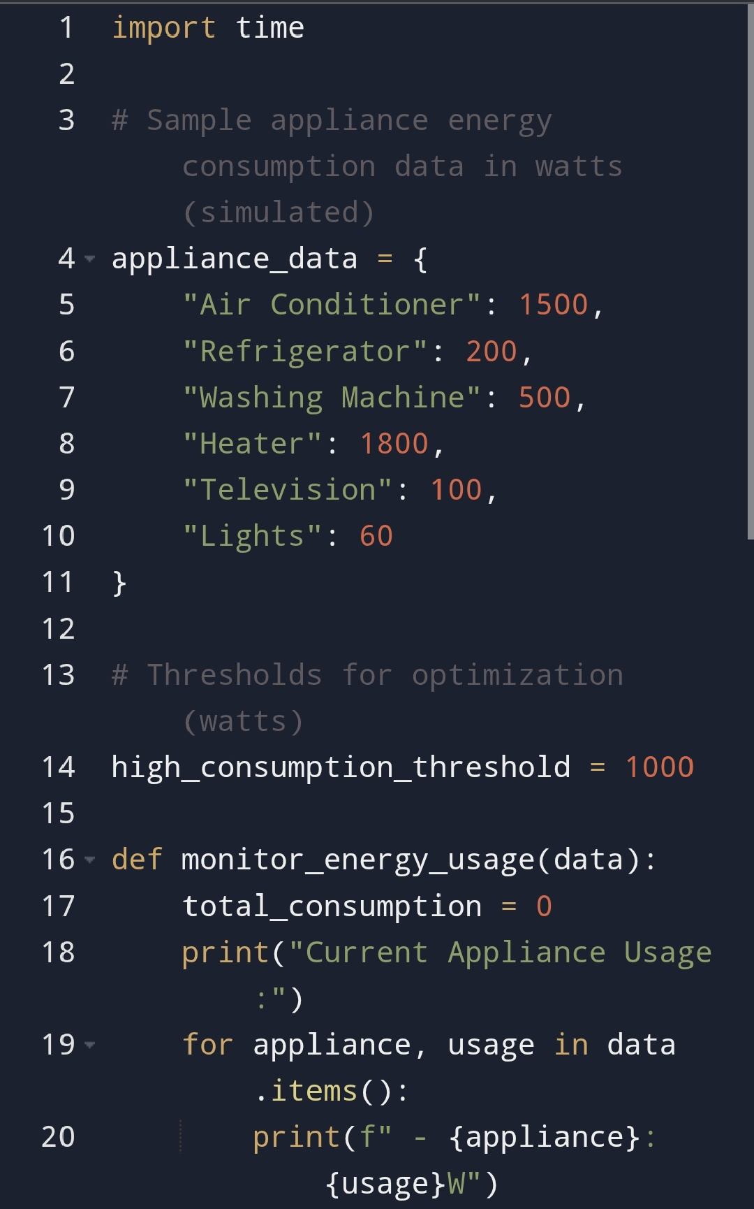

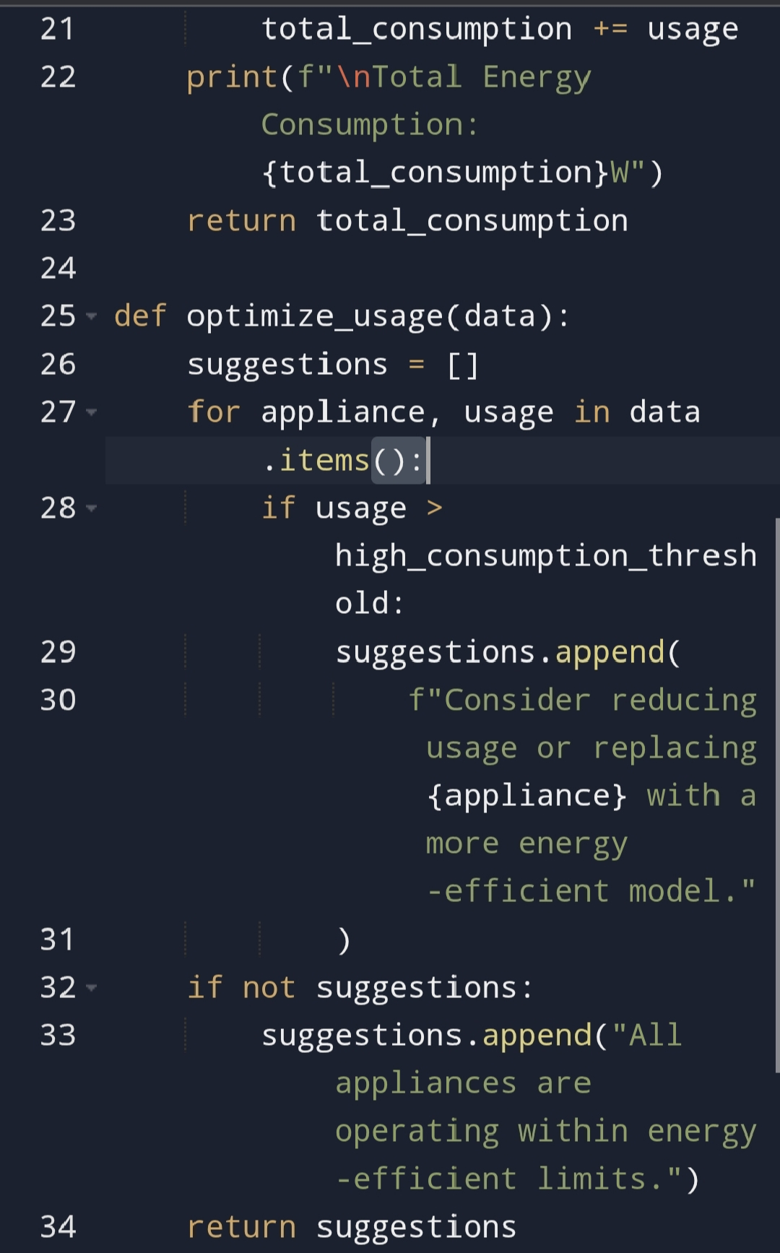

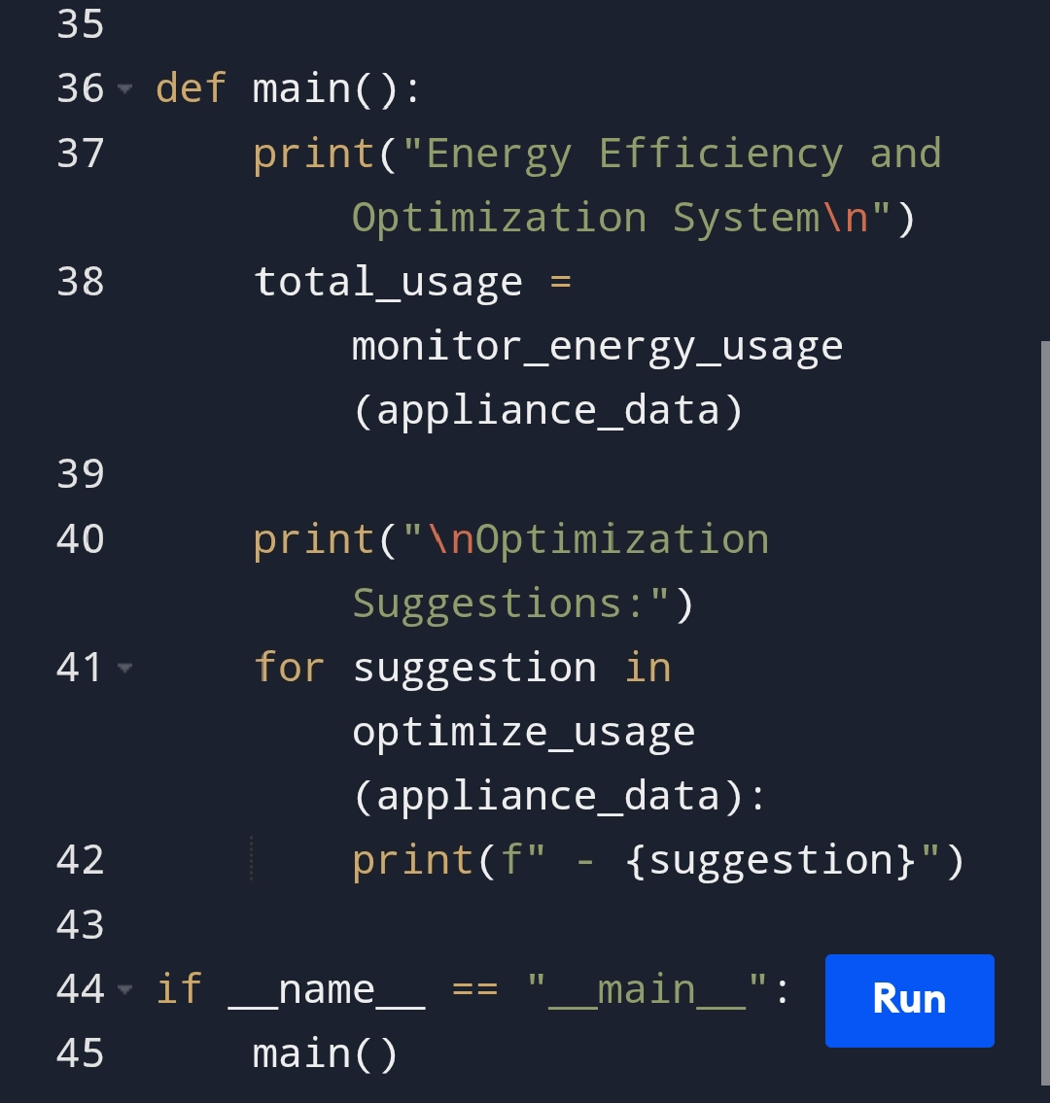

**Output**

